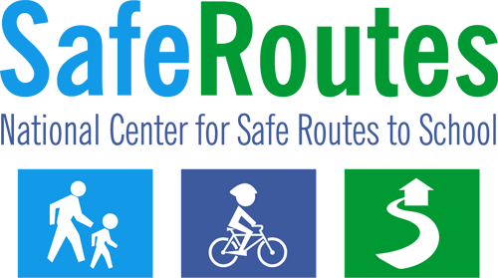

Walk to School Day Media Advisory
The following template media advisory can be tailored to give the media all of the general details of your Walk to School Day event – including the who, what, when, where and significance.

Using the Template

- Fill in the bracketed areas with your organization/event information.
- Logo: Please feel free to use the Walk to School Day logo or replace it with your own program logo. You may also choose to print the news release on your organization’s letterhead.

- Contact Information: It is important to choose a point person for the media advisory who will be available both once the advisory is distributed and throughout the event. Use the contact phone number that has the greatest likelihood of reaching the person.
- Identify Media Contacts: Use the media lists and instructions available to registered schools to identify the appropriate contact information for your local media.

- Distribution: About one to two weeks prior to the event, distribute the media advisory to local media contacts (television, radio and newspaper) via email, mail or hand-delivery.

Scroll down to page 2 for the media advisory.

FOR IMMEDIATE RELEASE  [Release date] | 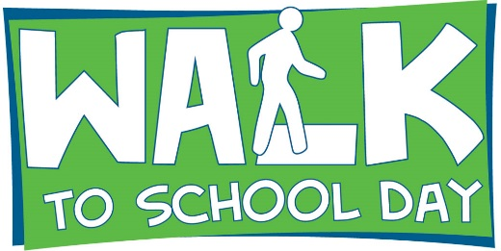 | CONTACT: [Name] [Phone number]  [Email address]

[City, county, area] school(s) to celebrate
International Walk to School Day on October [day, year]

WHAT: [Name of school, participating organizations, etc.] in [city] will be joining schools from around the world to celebrate International Walk to School Day on October [day, year].

WHO: [Name(s) of schools participating]
[Name(s) of community members participating]

WHERE: [Location where walkers will meet to walk together, or streets that children will be walking along. Include visual cues, i.e., next to the big oak tree]

WHEN: [i.e., Gather at 7 a.m., walk to begin at 7:15 a.m.]

SIGNIFICANCE: Approximately [number] students from [name of school(s) participating] will walk to school [day(s) of the week] along with parents, teachers and community leaders. [List any names and titles of participating community leaders or prominent figures].

In the United States, International Walk to School Day is expected to include more than 5,000 events across all 50 states. Walkers from the U.S. will join children and adults in 40 countries around the world.

Walk to School Day events work to create safer routes for walking and bicycling and emphasize the importance of issues such as increasing physical activity among children, pedestrian safety, traffic congestion, concern for the environment and building connections between families, schools and the broader community.

The event is being organized by [organizing group(s)]. [Include additional information about your program and how it fits into the larger picture for the community, whether it is part of a Safe Routes to School program, etc.]

Walk to School Day in the USA www.walktoschool.org
National Center for Safe Routes to School www.saferoutesinfo.org

###

